Digital Design Principles

Seven Segment Display

Name: Rajkaran Singh Grewal

Student No: 8882386

Email: rgrewal2386@conestogac.on.ca

Objective:

- Use VHDL to implement a binary to 7 Segment decoder.  
- Introduction to the VHDL Case statement.

Truth Table:

|  |  |  |  |  |
| --- | --- | --- | --- | --- |
| Sw3 | Sw2 | Sw1 | Sw0 | LED |
| 0 | 0 | 0 | 0 | 0 |
| 0 | 0 | 0 | 1 | 1 |
| 0 | 0 | 1 | 0 | 2 |
| 0 | 0 | 1 | 1 | 3 |
| 0 | 1 | 0 | 0 | 4 |
| 0 | 1 | 0 | 1 | 5 |
| 0 | 1 | 1 | 0 | 6 |
| 0 | 1 | 1 | 1 | 7 |
| 1 | 0 | 0 | 0 | 8 |
| 1 | 0 | 0 | 1 | 9 |
| 1 | 0 | 1 | 0 | A |
| 1 | 0 | 1 | 1 | B |
| 1 | 1 | 0 | 0 | C |
| 1 | 1 | 0 | 1 | D |
| 1 | 1 | 1 | 0 | E |
| 1 | 1 | 1 | 1 | F |

VHDL Introduction:

To make the program in VHDL we will need to initialize the library and entity. Within the entity we will state the 4 input switches and the seven segment display. Within the architecture of the program we will use case and when statement. Where for each different state the four inputs are the according segments of the seven segments display to light up the symbol to show the hexadecimal version of the input. The above truth table is the be followed to know which led is to be set accordingly.

VHDL program screenshot: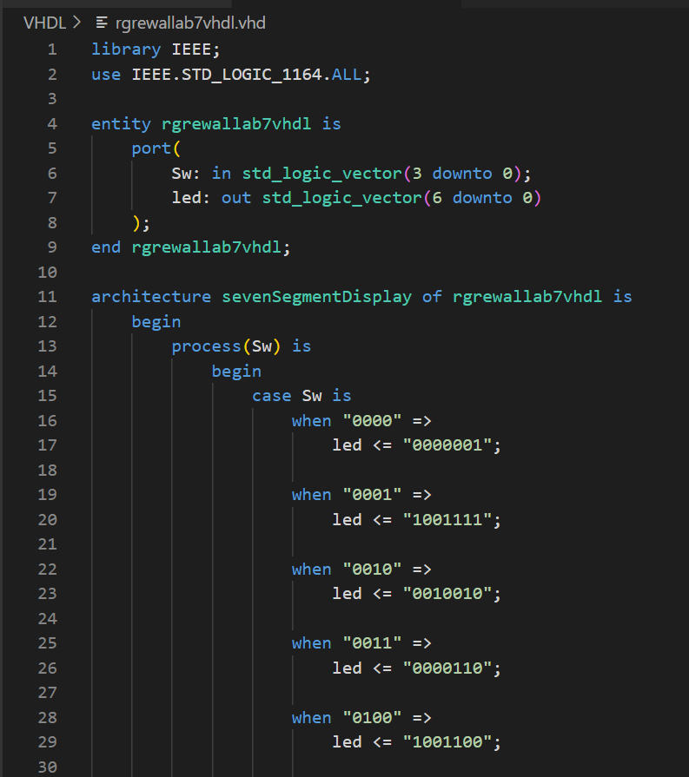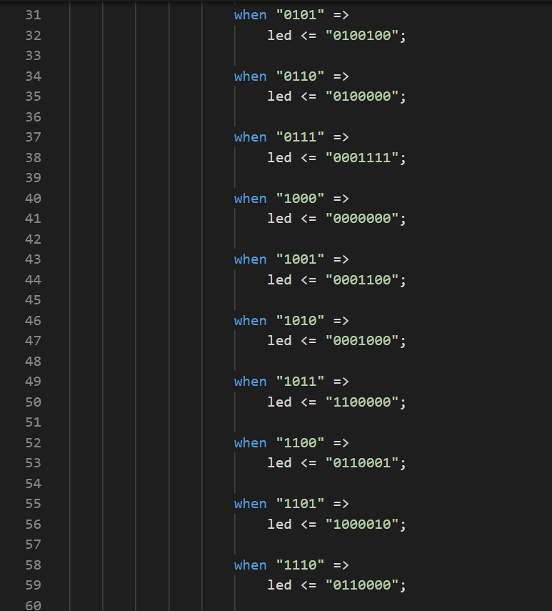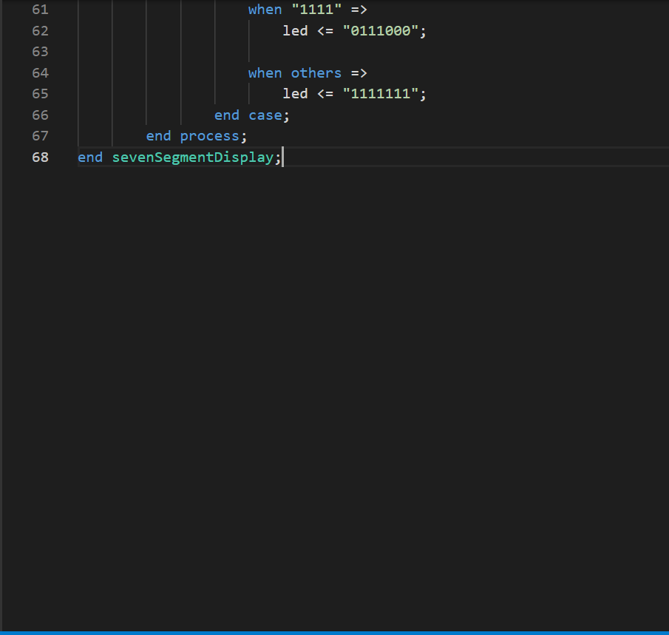

VHDL compilation report: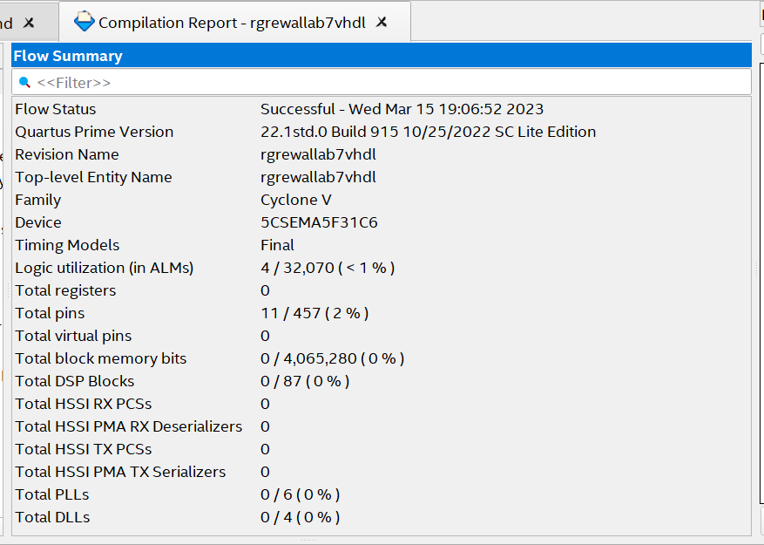

Pin Planner screenshot:

Verilog introduction:

For the program in Verilog we will need to initialize the module with the parameters having the four inputs and a seven segment display. Within the module block we use case where the output will assign the value according to the state of the input which matches to the truth table.

Verilog program screenshot: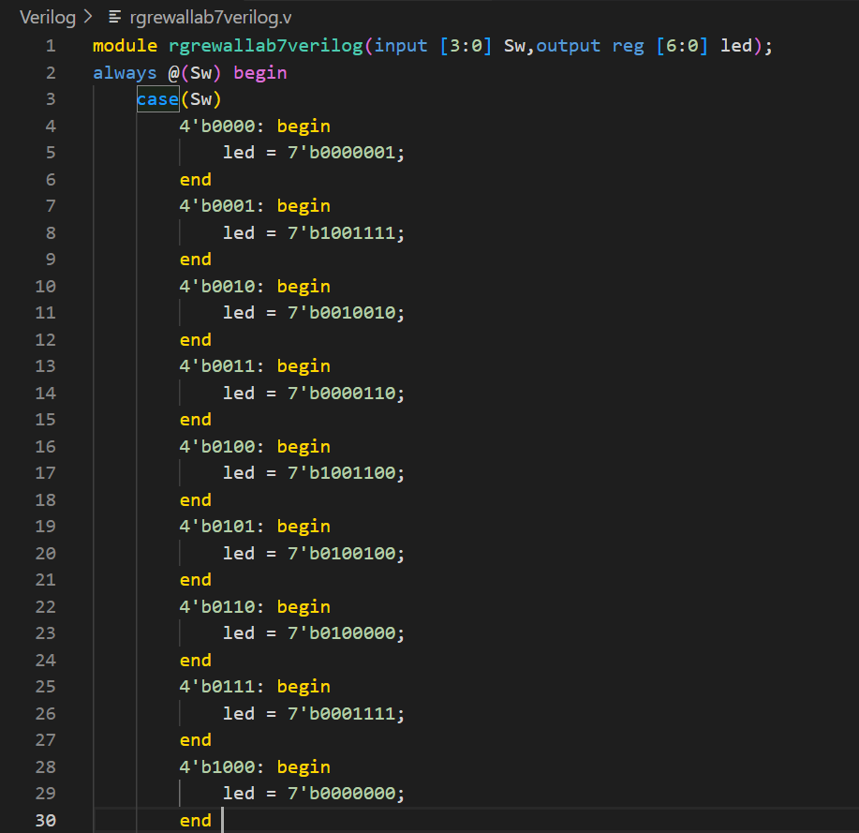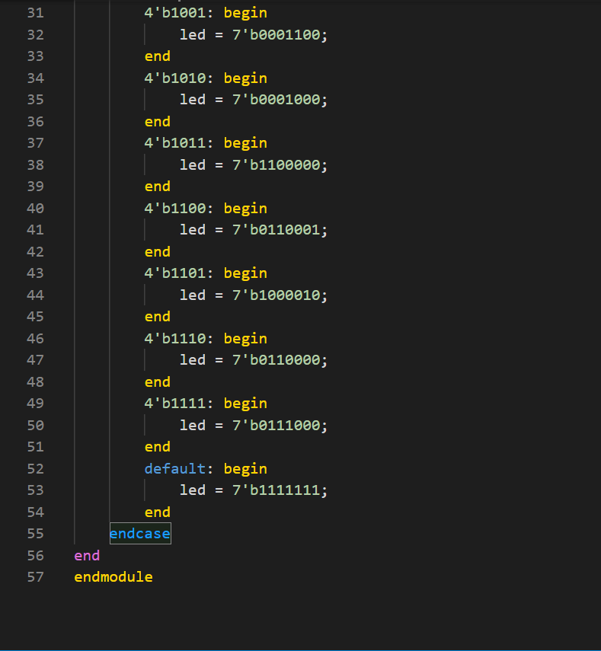

Verilog compilation report: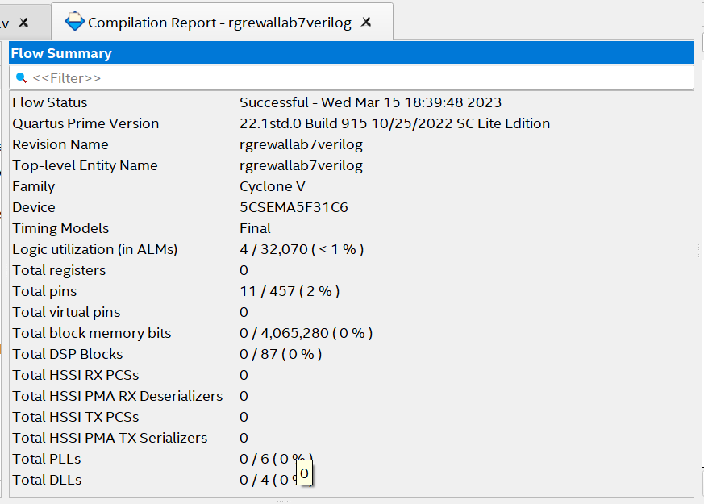

Conclusion:

Thus we can conclude that by both the programming languages we will use case statement and the one seven segment display which corresponds to the input will light up. The above truth table will be followed to show a binary to hexacode convertor.